- PROJECT TITLE : BANK MANAGEMENT SYSTEM

- PRESENTED BY
- ABDULLAH NAVEED ( 2025-CS-196 )

- INSTRUCTOR NAME
- SIR HAMZA FAROOQ

INTRODUCTION:

Banking systems play an important role in managing financial transactions such as account creation, deposits, withdrawals, and balance inquiries. In traditional systems, handling these operations manually can be time-consuming and prone to errors. With the help of programming, these processes can be automated to improve efficiency, accuracy, and reliability.
This project, titled “Bank Management System ” is a console-based application developed to simulate the basic working of a banking system. The system allows users to create bank accounts, deposit and withdraw money, check account balances, and securely manage their accounts using passwords. Additionally, an admin panel is included to view and manage all existing accounts.
The project is implemented using the C++ programming language and makes use of core programming concepts such as structures, functions, conditional statements, loops, dynamic memory allocation, and random number generation. The main objective of this project is to gain practical experience in problem solving and to understand how real-world banking operations can be modeled using programming logic.

SCOPE OF PROJECT:

- Multiple user account can be created.
- Can easily be used as based on totally menu , interface based.
- These accounts can be managed dynamically.
- Account numbers generated randomly.
- User can secure his account by password.
- Cash can be deposited and withdrawed.
- User can login to his account.
- Admin can view and manage all accounts.

SYSTEM DESIGN / LOGIC:

Used “ struct User”.
- Used dynamic array resizing with the help of new keyword.
- Generated random account numbers using seed value and rand() and srand() function.
- An account no validater function is used as a helper
( When the user enters his account number the account is first searched if it exists then the next operation can be performed.)

Dynamic Allocation Strategy:

- A dynamic array of structure “User” is created using new keyword.
- When the limit of accounts exceeds 100 it makes the capacity double and copies the previous data into new dynamic array.
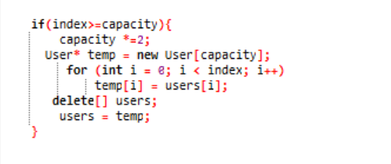
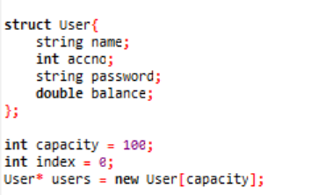

USER VIEW:

When the User enters the console the “ MAIN MENU ‘ is displayed giving the choices to enter:
- Admin Panel
- User Panel
- Login
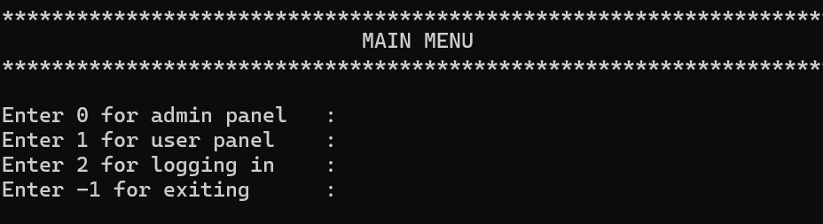
- Exit

(A validater do while loop is used to validate the user choice)

CHOICE == 1

User choose to enter the user panel and the following interface will appear:

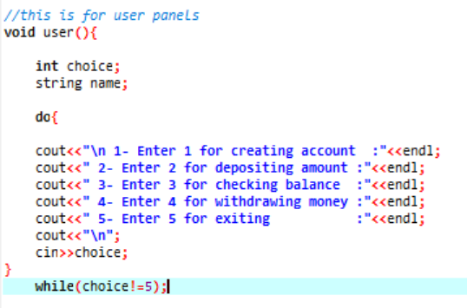

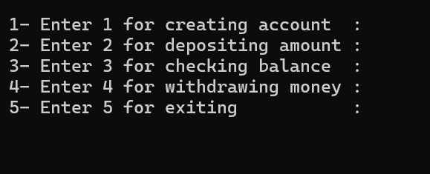

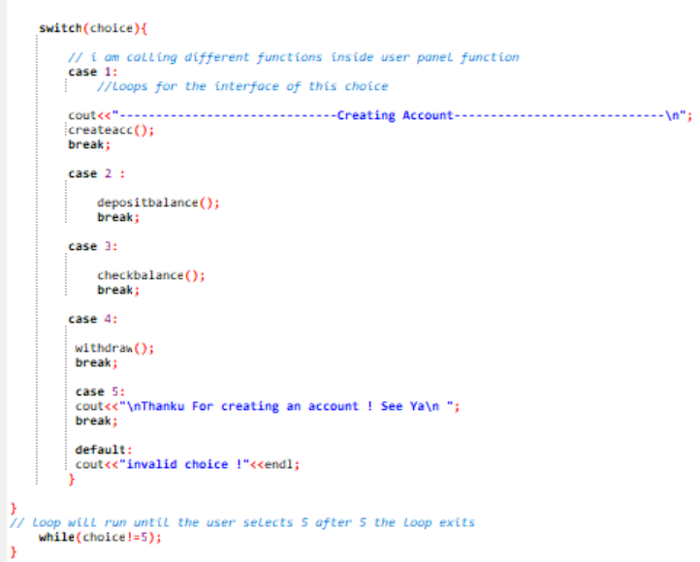
Used switch to create a menu based interface that will repeat until the user choose to exit.

FUNCTIONS DESCRIPTION:

Creating Account:
This function is used to create a new bank account. It takes user input such as name and password, generates a random and unique account number, initializes the balance to zero, and stores the account details in memory.
• Name input
• Password creation
• Random account number generation
• Initial balance = 0

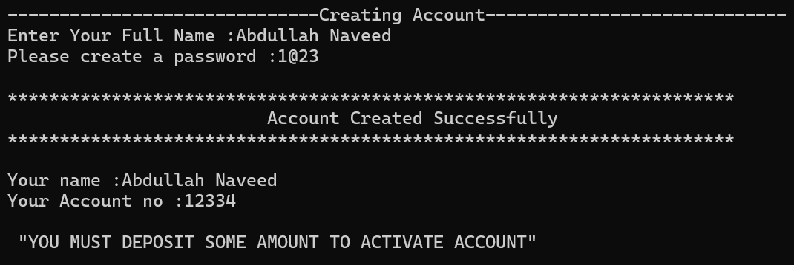

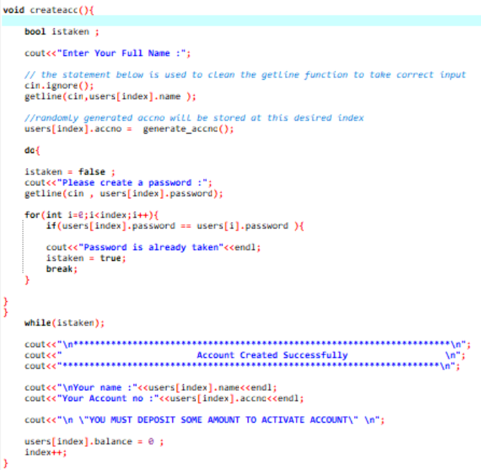

RANDOMLY GENERTAED ACCOUNT NO’S:

- Random Account No’s will be generated
- rand and srand functions are used
- If account no already exist it will again generate random acc no
- Code logic is below
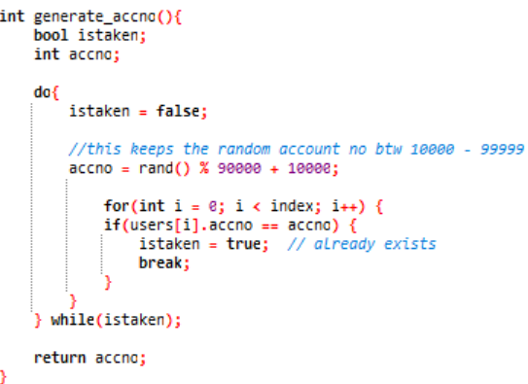

ACCOUNT NO VALIDATER:

- This function take accno from the user as an argument and check wether the account exists or not.
- If account exists it will return the index of that account.
- If it does not exist it will return -1.
- This validater will be used everywhere before performing any operation.

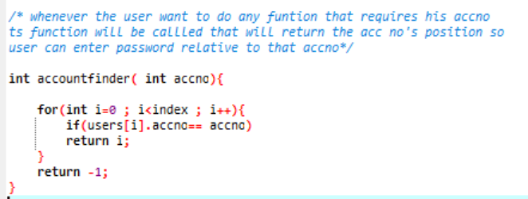

DEPOSIT AMOUNT:
- It will first check wether the account exist.
- If it exists it will return the position of the concerned account and that will be stored in a variable.
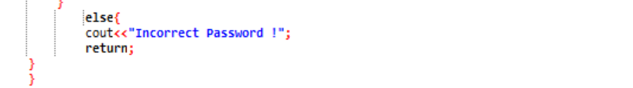
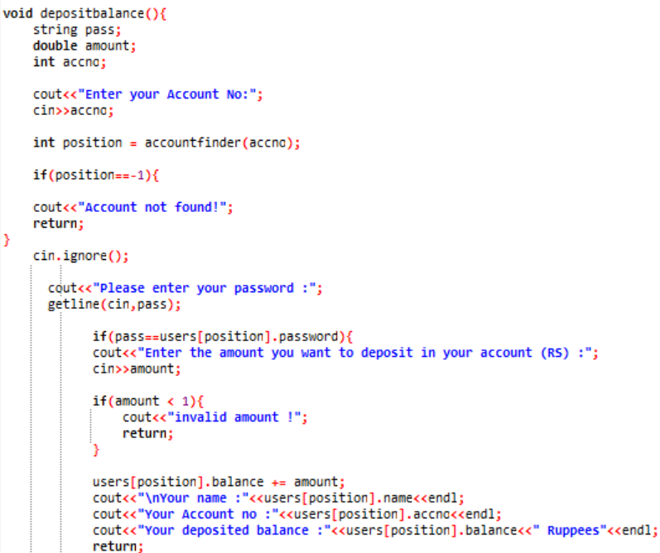
- Then password for that account will be validated if successful the user will be allowed to deposit money greater then 1.

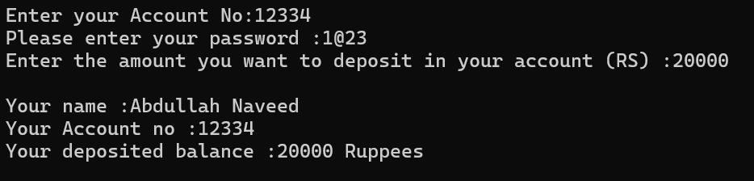

--------------------------------------------------------------------------------------------------------------------------

CHECKING BALANCE:

- Again the input account no will be validated using validater and the regarding position will be stored in variable
- After validation user will enter respective password for that account if correct it will display the balance of that account.

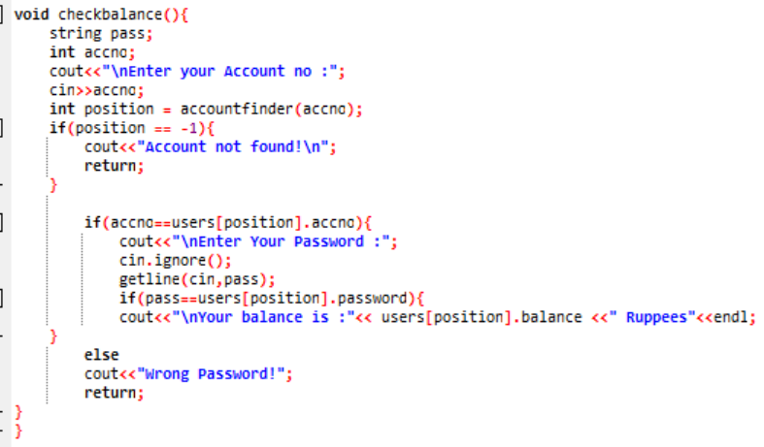

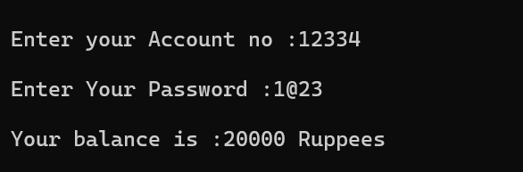

WITHDRAW AMOUNT:
- User will enter his Account no it will be verified first if exists its relative position will be returned.
- User then has to enter his pass if correct he will be able to withdraw money.
- The amount cannot be less then 1.
- It is acting like an ATM machine.
- After withdrawal user will be able to see his remaining balance.

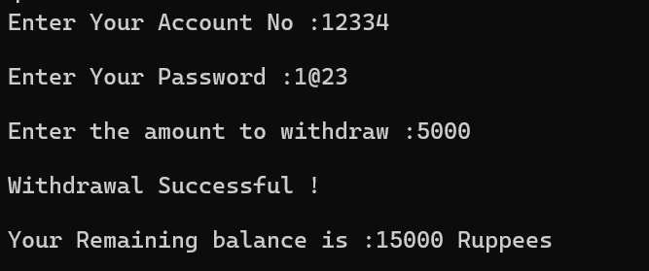

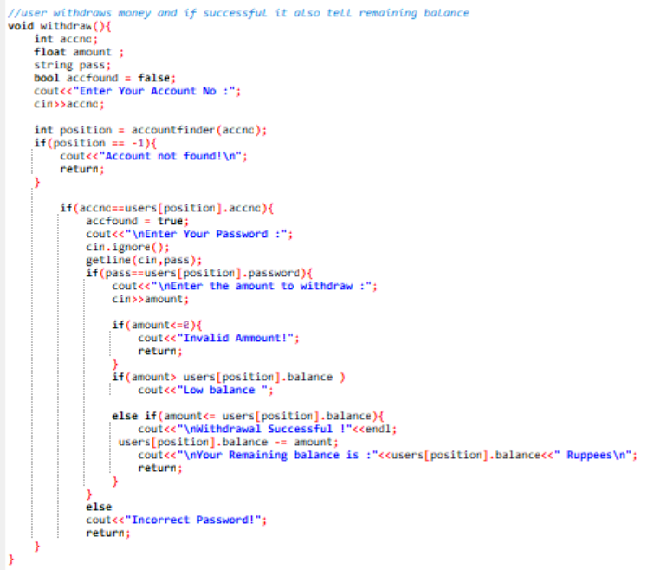

CHOICE == 2 / LOGIN:
- User will login to his account after entering his account no and password.
- User is able to change his pass, and deposit balance.
- It is also switch based menu driven interface.

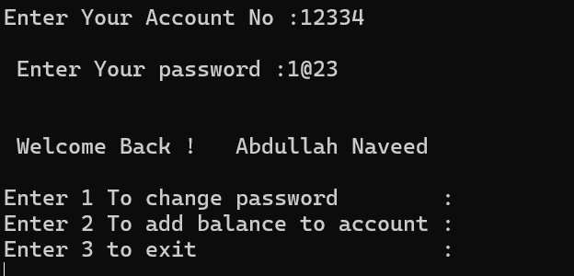

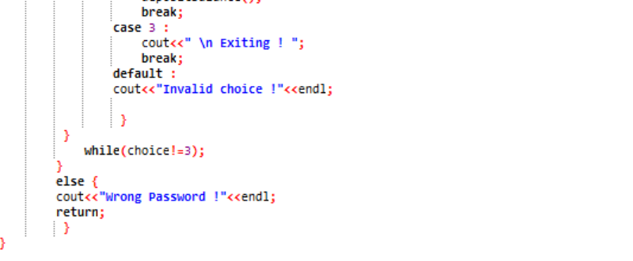
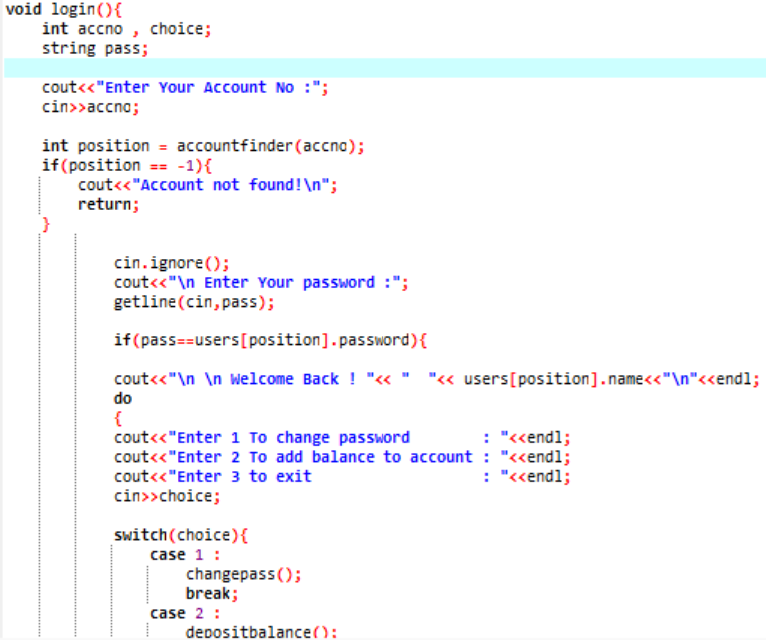

Change Password:
- User will give his account no and his previous password after validation user will be able to change his password.
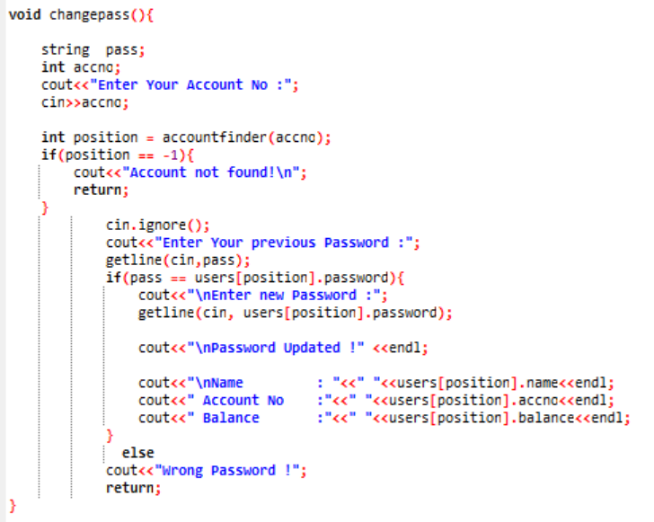
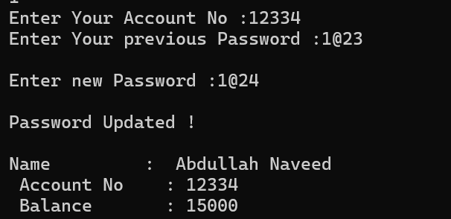

DEPOSIT AMOUNT:

For deposit amount again the deposit amount function will run as discussed earlier.

------------------------------------------------------------------------------------

ADMIN PANEL

- Admin is the person who can view or delete all accounts created
- First admin has to validate the hardcoded password for the admin access.
- After validation admin will be able to to make changes of his desire.

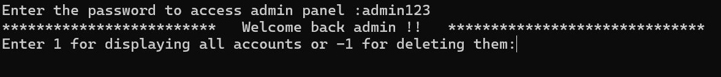

Displaying All Acounts:

Admin just press 1 and all accounts created in the bank will be visible to him
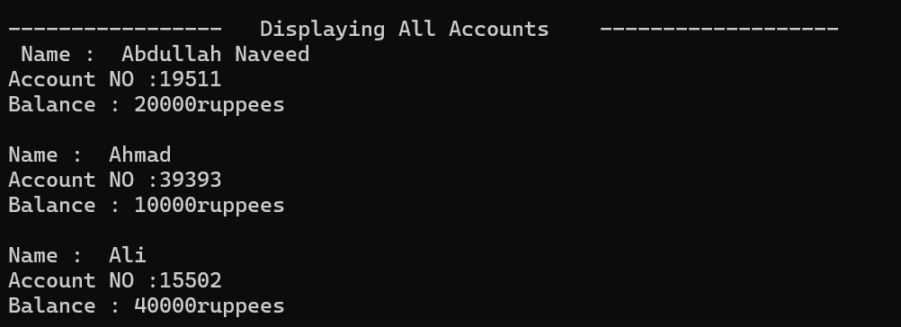

Deleting All Accounts:
Admin presses -1 and all accounts will go vanish and deleted.

